***SUMMARY***

I graduate from Addis Abeba university with B.Sc. in public Administration and Development management .I am open minded, self-initiated, detailed oriented and teachable person. I am highly organized, efficient, energetic, innovative, and proactive student with healthy and capable of doing any type of work.

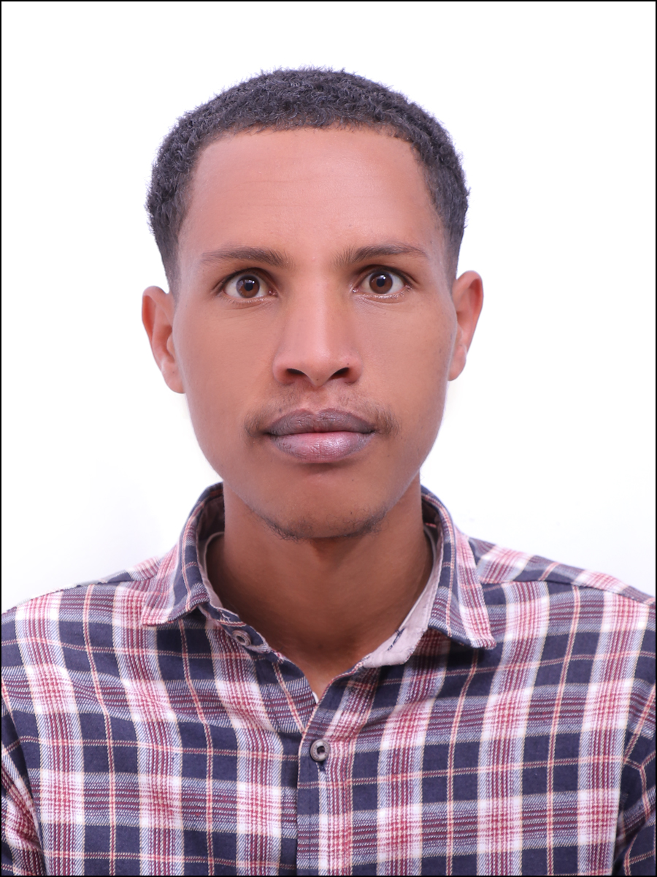



**TAJU AHMED HUSSEN**

**EDUCATION**



**0987001303**

**tajua4591@gmail.co**

**Addis Abeba Ethiopia**



* Bachelor of art in Public administration and development management

**Skills**

**Work Experience**

**Intern**

* Bunna Bank Two Months internship Training from June 2023 to September 2023

* Good leadership skill
* Excellent Communication skill
* Computer skill
* Strong leadership skills and ability to motivate people.

**LANGUAGES**

* **ENGLISH**
* **AMHARIC**

**HOBBIES**

* **TEACHING**
* **READING**
* **SPORTS**
* **LEARNING NEW SKILLS**

**Reference**

Dr. Mulugeta Yohannes

Email: mulugetayohannes@aau.edu.et

**Certificates and Recognition's**

* I have received training in employ ability skills and career development at the dereja & addis ababa university
* I have a two day training certificate for addis ababa university career counseling students
* I have social entrepreneurship online training certificate from hp foundation & YMCA Ethiopia
* I Have Digital world training held by kemmcom in partnership with meta